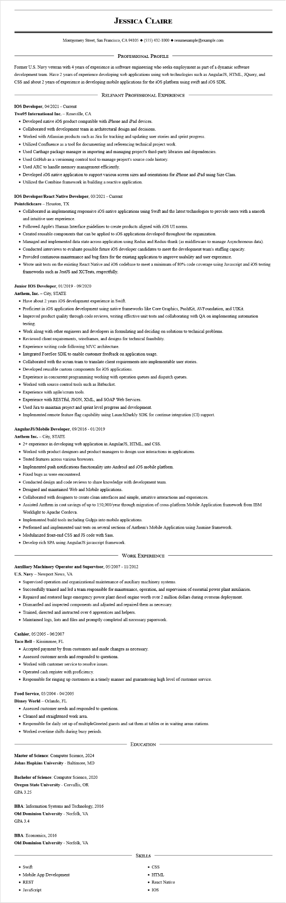
JESSICA CLAIRE
Montgomery Street, San Francisco, CA 94105 ♦ (555) 432-1000 resumesample@example.com
PROFESSIONAL PROFILE
Former U.S. Navy veteran with 4 years of experience in software engineering who seeks employment as part of a dynamic software development team. Have 2 years of experience developing web applications using web technologies such as AngularJS, HTML, JQuery, and CSS and about 2 years of experience in developing mobile applications for the iOS platform using swift and iOS SDK.
RELEVANT PROFESSIONAL EXPERIENCE
IOS Developer, 04/2021 - Current
Two95 International Inc. - Roseville, CA
• Developed native iOS product compatible with iPhone and iPad devices.
• Collaborated with development team in architectural design and decisions.
• Worked with Atlassian products such as Jira for tracking and updating user stories and sprint progress.
• Utilized Confluence as a tool for documenting and referencing technical project work.
• Used Carthage package manager in importing and managing project's third-party libraries and dependencies.
• Used GitHub as a versioning control tool to manage project's source code history.
• Used ARC to handle memory management efficiently.
• Developed iOS native application to support various screen sizes and orientations for iPhone and iPad using Size Class.
• Utilized the Combine framework in building a reactive application.
IOS Developer/React Native Developer, 03/2021 - Current
Pointclickcare - Houston, TX
• Collaborated in implementing responsive iOS native applications using Swift and the latest technologies to provide users with a smooth and intuitive user experience.
• Followed Apple's Human Interface guidelines to create products aligned with iOS UI norms.
• Created reusable components that can be applied to iOS applications developed throughout the organization.
• Managed and implemented data state across application using Redux and Redux-thunk (as middleware to manage Asynchronous data).
• Conducted interviews to evaluate possible future iOS developer candidates to meet the development team's staffing capacity.
• Provided continuous maintenance and bug fixes for the existing application to improve usability and user experience.
• Wrote unit tests on the existing React Native and iOS codebase to meet a minimum of 80% code coverage using Javascript and iOS testing frameworks such as JestJS and XCTests, respectfully.
Junior IOS Developer, 01/2019 - 09/2020
Anthem, Inc. - City, STATE
• Have about 2 years iOS development experience in Swift.
• Proficient in iOS application development using native frameworks like Core Graphics, PushKit, AVFoundation, and UIKit.
• Improved product quality through code reviews, writing effective unit tests and collaborating with QA on implementing automation testing.
• Work along with other engineers and developers in formulating and deciding on solutions to technical problems.
• Reviewed client requirements, wireframes, and designs for technical feasibility.
• Experience writing code following MVC architecture.
• Integrated ForeSee SDK to enable customer feedback on application usage.
• Collaborated with the scrum team to translate client requirements into implementable user stories.
• Developed reusable custom components for iOS applications.
• Experience in concurrent programming working with operation queues and dispatch queues.
• Worked with source control tools such as Bitbucket.
• Experience with agile/scrum tools.
• Experience with RESTful, JSON, XML, and SOAP Web Services.
• Used Jira to maintain project and sprint level progress and development.
• Implemented remote feature flag capability using LaunchDarkly SDK for continue integration (CI) support.
AngularJS/Mobile Developer, 09/2016 - 01/2019
Anthem Inc. - City, STATE
• 2+ experience in developing web application in AngularJS, HTML, and CSS.
• Worked with product designers and product managers to design user interactions in applications.
• Tested features across various browsers.
• Implemented push notifications functionality into Android and iOS mobile platform.
• Fixed bugs as were encountered.
• Conducted design and code reviews to share knowledge with development team.
• Designed and maintained Web and Mobile applications.
• Collaborated with designers to create clean interfaces and simple, intuitive interactions and experiences.
• Assisted Anthem in cost savings of up to 150,000/year through migration of cross-platform Mobile Application framework from IBM Worklight to Apache Cordova.
• Implemented build tools including Gulpjs into mobile applications.
• Performed and implemented unit tests on several sections of Anthem's Mobile Application using Jasmine framework.
• Modularized front-end CSS and JS code with Sass.
• Develop rich SPA using AngularJS javascript framework.
WORK EXPERIENCE
Auxiliary Machinery Operator and Supervisor, 05/2007 - 11/2012
U.S. Navy - Newport News, VA
• Supervised operation and organizational maintenance of auxiliary machinery systems.
• Successfully trained and led a team responsible for maintenance, operation, and supervision of essential power plant auxiliaries.
• Repaired and restored large emergency power plant diesel engine worth over 2 million dollars during overseas deployment.
• Dismantled and inspected components and adjusted and repaired them as necessary.
• Trained, directed and instructed over 6 apprentices and helpers.
• Maintained logs, lists and files and promptly completed all necessary paperwork.
Cashier, 05/2005 - 06/2007
Taco Bell - Kissimmee, FL
• Accepted payment by from customers and made changes as necessary.
• Assessed customer needs and responded to questions.
• Worked with customer service to resolve issues.
• Operated cash register with proficiency.
• Responsible for ringing up customers in a timely manner and guaranteeing high level of customer service.
Food Service, 03/2004 - 04/2005
Disney World - Orlando, FL
• Assessed customer needs and responded to questions.
• Cleaned and straightened work area.
• Responsible for daily set up of multipleGreeted guests and sat them at tables or in waiting areas stations.
• Worked overtime shifts during busy periods.
EDUCATION
Master of Science: Computer Science, 2024 Johns Hopkins University - Baltimore, MD
Bachelor of Science: Computer Science, 2020 Oregon State University - Corvallis, OR GPA 3.25
BBA: Information Systems and Technology, 2016
Old Dominion University - Norfolk, VA
GPA 3.4
BBA: Economics, 2016
Old Dominion University - Norfolk, VA
SKILLS
• Swift
• Mobile App Development
• REST
• JavaScript
• CSS
• HTML
React Native
• IOS

